Project Logbook for Virtual Campus

UNIVERSITY of reading | jAMES TANG | 24015209

Table of Contents

Signoff table and summary 2

1 – Choosing a project theme 3

2 – Research on project 3

3 – Choosing and testing programs 3

4 – Testing out Unity 3

5 – Testing out SketchUp 4

6 – Choosing movement type 5

Teleport based movements 5

Free movement 5

Waypoint movement 5

Conclusion 6

7 – First initial prototype 6

8 – Importing terrain 6

9 – Restarting again 6

10 – Adding terrain 6

11 – Photoshoot of buildings 7

12 – Texturing of the ground 7

13 – Adding in movement 8

14 – Adding in central buildings 8

15 – Creating Lake 9

16 – Adding in voices 10

17 – Implementation of adding voices 10

18 – First build of the project 11

19 – First demo of the project 11

20 – Importing to GitHub 11

21 – Adding trees to campus 11

References 13

Signoff table and summary

|  |  |  |
| --- | --- | --- |
| Date | Summary of date/week | Signature |
| 18.09.17 | Choosing project theme |  |
| 10.10.17 | Research on project |  |
| 13.10.17 | Choosing and testing programs |  |
| 16.10.17 | Testing out Unity |  |
| 18.10.17 | Testing out SketchUp |  |
| 20.10.17 | Choosing movement type |  |
| 6.11.17 | First initial prototype |  |
| 17.11.17 | Importing terrain |  |
| 20.11.17 | Restarting again |  |
| 21.11.17 | Adding terrain |  |
| 30.11.17 | Photoshoot of buildings |  |
| 4.12.17 | Texturing of the ground |  |
| 11.12.17 | Adding in movement |  |
| 8.1.18 | Adding in central buildings |  |
| 18.1.18 | Creating Lake |  |
| 25.1.18 | Adding in voices |  |
| 26.2.18 | Implementation of adding voices |  |
| 8.2.18 | First build of the project |  |
| 15.2.18 | First demo of the project |  |
| 19.2.18 | Importing to GitHub |  |
| 26.2.18 | Adding trees to campus |  |

# 1 – Choosing a project theme

For my Final Year Project, I must choose a project theme, so out of all the project choices I end up choosing, I chose Virtual Campus because it was the most interesting to me out of all the project theme choices and I have a keen interest in Virtual Reality. So, this was the perfect choice for me.

# 2 – Research on project

To do research on my project, I decided to research on multiple topics, such as how will the campus looks like in reality and how I will design the buildings, what programs I will use to achieve my goals, why am I creating this virtual campus and who is the target audience for. The next sections in this logbook will explain in detail about most of the goals.

For my target audience, I decided to base this on users who wanted to attend this university but however they are not able to attend the open days for a matter of factors (such as money issues, location/distance and/or bad timing). So, I decided to make this virtual campus for employees of university to bring the open day to them instead of them coming here. The application was originally going to be created for Windows but instead I switched to Android devices because most users today have virtual reality installed on their phones. Also, there is the possibility that their computers may not have the hardware to run virtual reality. So, I switched to android devices so users can install the application to their phones at any point even if they miss out the chance if test out the virtual reality campus on an open day.

# 3 – Choosing and testing programs

I had to choose and test programs to create the Virtual Campus, I decided to go with the recommend programs that the University provided me, which were Unity, SketchUp and Blender. The next two sections explain in detail about how the testing went. However, I didn’t use Blender because I found Blender to complex and difficult compared to using SketchUp to model buildings.

# 4 – Testing out Unity

I have tested out Unity, to see if it is suitable for helping me creating the main virtual reality program itself. I have never tried Unity before however it provides an easy to use tutorial and allows the user to understand the basics. Thanks to the tutorial provided and the easy to use interface of creating game, I will be using unity to create the Virtual Campus.

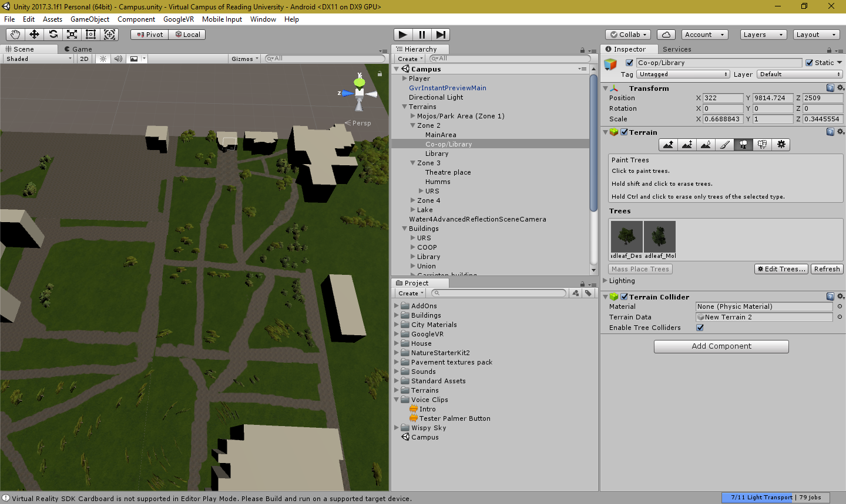

Figure 1 Screenshot of unity

# 5 – Testing out SketchUp

I have tested out SketchUp, to see if it is suitable for helping me create my models. I was familiar with SketchUp before, but I decided to test the program again, SketchUp Allows for easier building creation compared to blender, as it allows to create buildings via sculping where you draw an outline of the building and then you use the pull function to generate an 3D version of the outline of the building, I decided to use SketchUp for building generation as it allows for easy building creation and texturing.

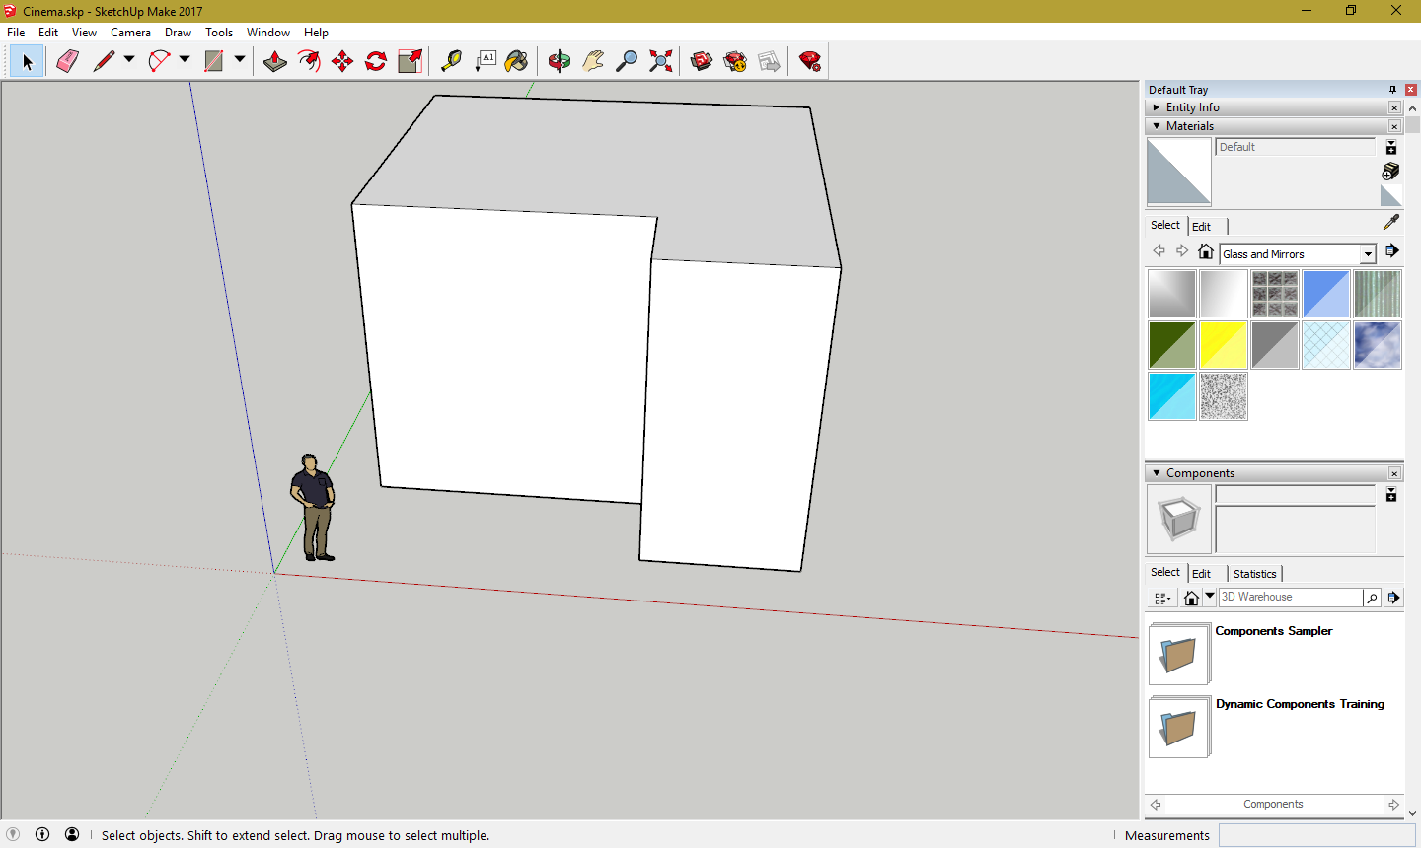

Figure 2 Screenshot of SketchUp

# 6 – Choosing movement type

To choose the movement type of moving around the virtual campus, I had to research the possible types of movement in virtual reality. The three movement types that interested me were:

1. Teleport based movement
2. Free movement
3. Waypoint movement

## Teleport based movements

Teleport based movements was the first movement that I researched after watching VR games that used this movement. Teleport based movement allows users to point at a location they wish to transport to via an indicator appearing. They press a button to instantly be teleported there, they can teleport to any place that they wanted granted they have permissions to do so.

## Free movement

Free movement allows users to move in a direction that they want, without needing to pause. This allows for the most realistic movement of virtual reality however it causes the most motion sickness as their eyes believe that they are moving however their body in real life isn’t. So, in the end I won’t be using free movement as not many people have been exposed to Virtual Reality.

## Waypoint movement

Waypoint movement allows users to choose a node or a point on the screen, that the programmer specified and the user can look at the node and then press a button to be teleported to that node. It allows the safest amount of moment for Virtual reality as compared to teleport based movement, users can potentially find errors and glitch by teleporting out of bounds by mistake, however it is the least restricted out of the three movement types are users are limited to moment by the nodes specified.

## Conclusion

In conclusion, I chose teleport based movement because in the end, teleport based movement allows for the freest movement type of out of the three and it’s the movement type that will cause the least amount of motion sickness to the user and the user only moves when they want to move and it’s done via teleportation instead of free movement.

# 7 – First initial prototype

The first initial prototype of the first program was basically me trying to test out unity’s Virtual Reality features as well as exporting to android devices. The first scene allowed you to view a house, move your head around the environment however you weren’t allowed to move because it wasn’t implemented yet. It also had interactivity as you could press a button on the house which played an audio clip. Originally the virtual campus was going to be exported to Windows.

# 8 – Importing terrain

To import the terrain, Tim Threadgold helped me import the terrain by using a website (Darrenlloyd, 2013), that allows you to create terrains from Google Maps by creating a heightmap for photoshop. Tim Threadgold helped me by sending me the files of the heightmap as I lacked Photoshop (As the website uses the photoshop scripts to create the terrain’s heights) to create the heightmap for the terrain.

Once the files have been imported into Unity, then I created a terrain and imported the heightmap into it, thus making the terrain of the campus. Despite how easy it sounded on paper and I was well ahead of finishing the Virtual Tour of campus, a problem occurred.

# 9 – Restarting again

Despite easily importing the terrain into the initial Whiteknights campus Terrain, there was a major problem with the initial terrain, the terrain was too big for the entire campus and there was a lot of issues rendering all the terrain and the shadows. It took too long to render not to mention if this is the issue of rendering every detail of the campus on my PC. Then chances are that my phone will not be able to render correctly when exported to android devices. So thus, the decision was made to restart the entire campus terrain from scratch and recreate it again.

# 10 – Adding terrain

Adding in terrain after restarting the entire campus again, was simpler and easier to render and build on my computer than the previous incarnation. To build the campus grounds again, I did a 3 by 3 square grid consisting of different terrains. So, it would be easier to paint pavements into the terrains. I based the terrain’s positions based on Google maps, facing east.

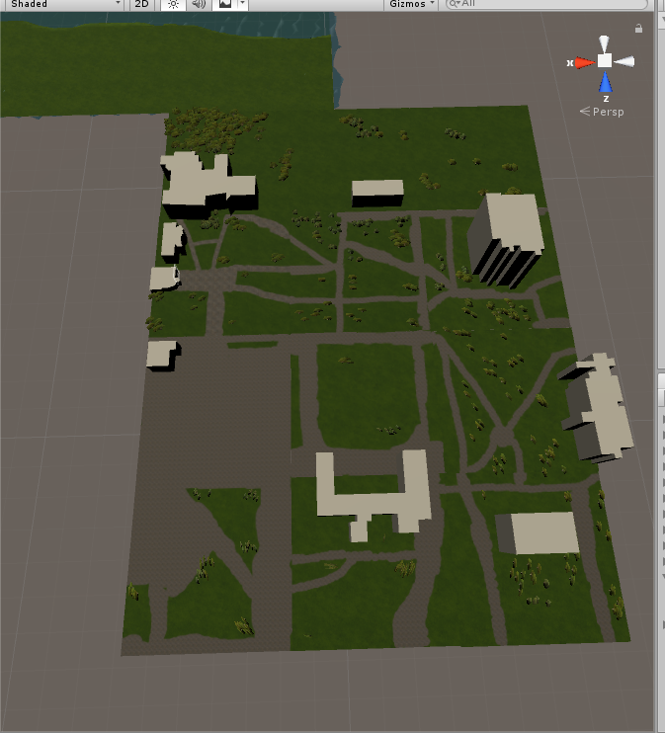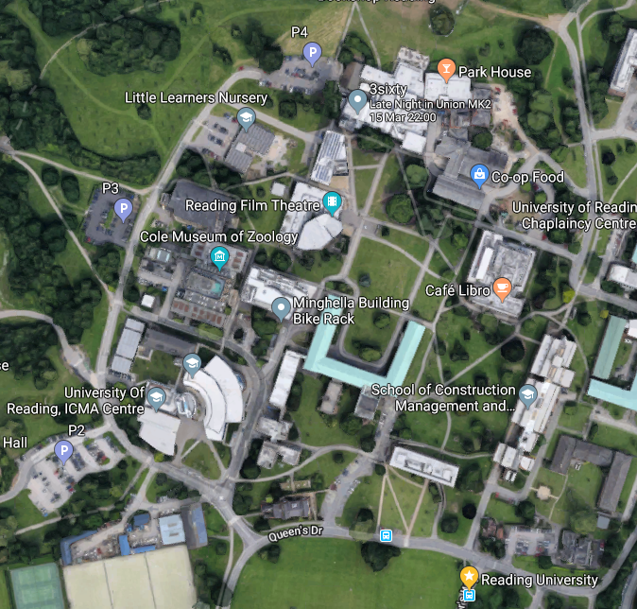

Figure 3 Comparison of using terrain for unity and campus grounds

# 11 – Photoshoot of buildings

To get referencing of what the buildings around Whiteknights campus and to somewhat accurately model the buildings. I decided to go to Whiteknights campus in real life and took photos of the various buildings that I intend to model inside the virtual campus. All of the photos I took for referencing can be found here: <https://drive.google.com/drive/folders/1eXYKl3vXmljyhCB6fUtWI806828mBcG4?usp=sharing>.

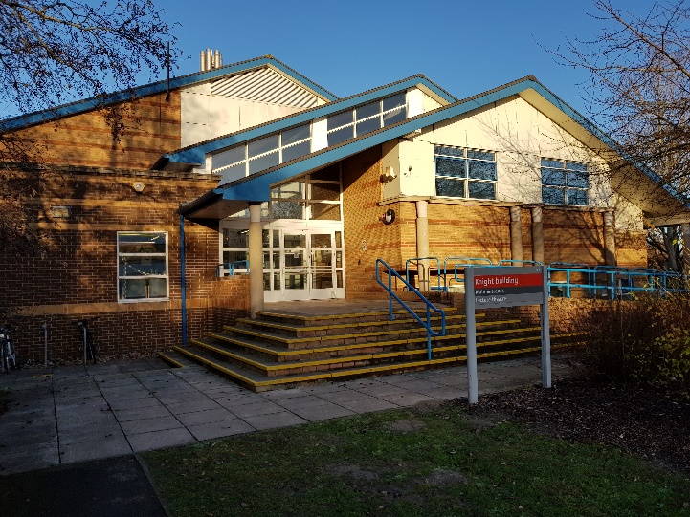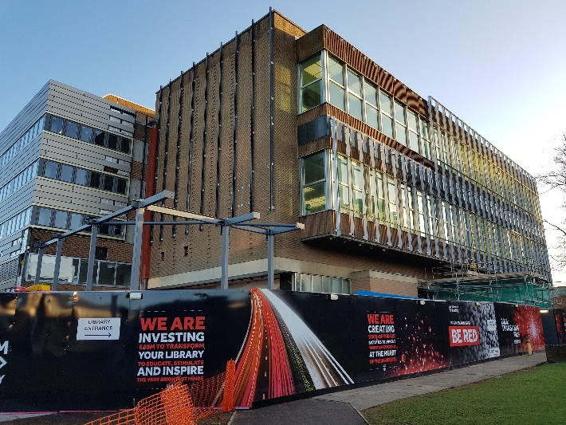

Figure 4 Photos of buildings that I took, the photos are buildings of the Knights Building and Library

# 12 – Texturing of the ground

To texture the grounds of the campus, I used the terrain painting tool in unity. First, I had to add in a base texture, which I used Unity’s standard assets for the grass texture which paints the entire terrain in grass, (as most of Whiteknights’ campus is grassy). To add pavements in campus, I used a paintbrush tool to paint directly onto the terrain. The texture used to make the pavement was from (Nobiax, 2014). I painted the pavement based on google maps’ satellite view.

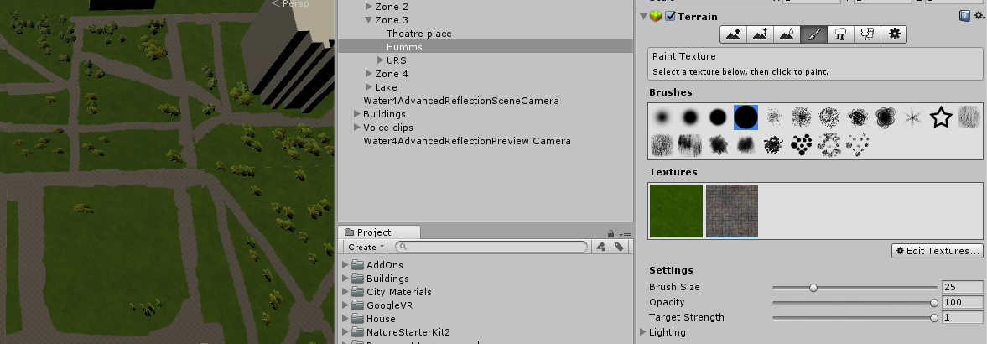

Figure 5 Using the texture tool in unity

# 13 – Adding in movement

To add in movement, I followed a YouTube tutorial (BrainSock, 2016) to add in teleport based movements, most of the code was already done by the tutorial and I used the prefab that he had provided already into the existing project. I have tweaked some of the code to make it easier for the user (Such as making the line bold).

# 14 – Adding in central buildings

To add in the central buildings, I have created and texturized every building using SketchUp. After each building was created, it was exported in a .skb file in order for it to be used in Unity. Afterwards the buildings are imported to unity and then placed inside the Virtual Campus, the buildings were placed in positions according to Google Maps.

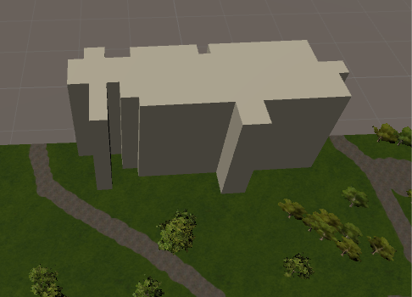

Figure 6 Adding in a building to campus grounds (texture added later after this project logbook was made)

# 15 – Creating Lake

To create the lake in the campus, a terrain was created first, to sculp the terrain, I had to change the terrain height (Terrain height is defaulted to 0, you can rise terrain however you cannot lower terrain which I wanted to do). Then sunk the terrain to make the lake, afterwards to add in the water, I imported the environment standard assets from unity and then I added a Water prefab into the lake, by placing it in the areas where the terrain has been lowered and thus creating the lake.

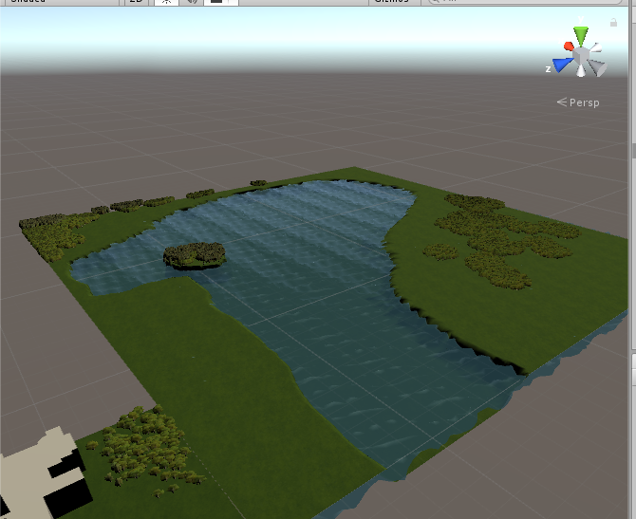

Figure 7 What the lake looks like in unity

# 16 – Adding in voices

I have added in voices, using a microphone and following a script that I have created. All audio was recorded using audacity.

# 17 – Implementation of adding voices

To successfully implement voices into the world for when the user wants to find out the history of the building. A button was created next to the buildings then when the user walks up to the button and presses it, then the sound clip will be activated playing the voice. To achieve this, the button was first created along with coding of what sound clip will be played when the button is pressed, afterwards the button is then added to world (It is usually defaulted to the User Interface) and then afterwards the button is placed next to the assigned building.

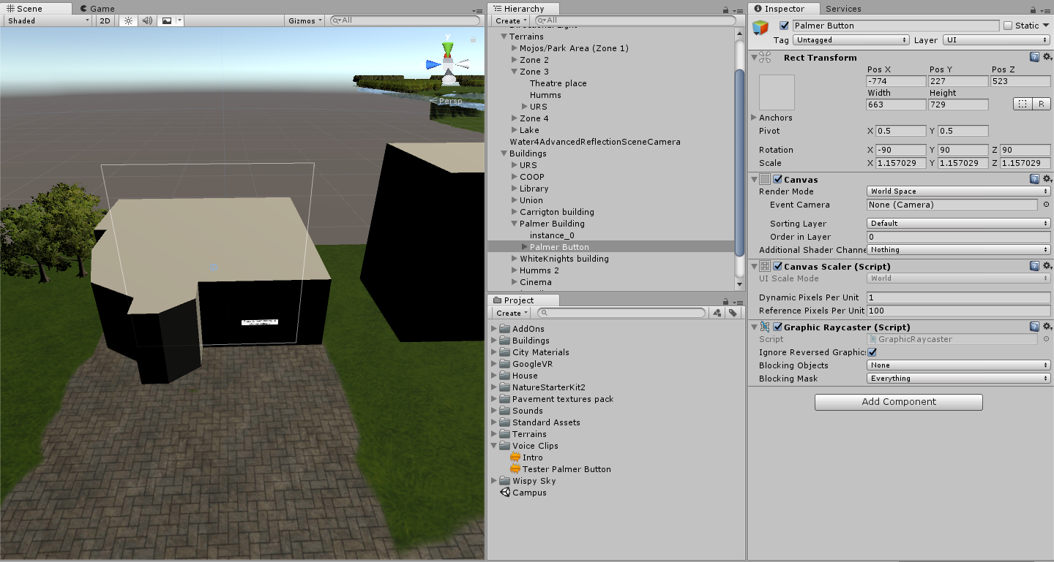

Figure 8 Implementing the button into the world, so users can press a button a voice clip will play explaining the backstory of this building

# 18 – First build of the project

The first build of the project was made using the Unity build settings. The settings exported was using Android, 32 bits and was built for nougat devices or higher (7.0 or higher). As older versions of android won’t be supported as they do not have daydream or cardboard installed (the service to run virtual reality on Android devices).

The first build was successful as it suffered no errors and bugs during launch and everything ran fine according to how it was built.

# 19 – First demo of the project

The first demo

# 20 – Importing to GitHub

I have imported the entire project into GitHub (In hindsight, this should have been done earlier however due to previously having a lack of knowledge and not feelings like I should use it, is the main reason why I didn’t use it until 19th February). The link can be found here: <https://github.com/JamesTang2905/Individual-Project-2017-18>

# 21 – Adding trees to campus

I have added trees from unity using the tree tool in the terrain settings. I have place trees based on the position of google maps.

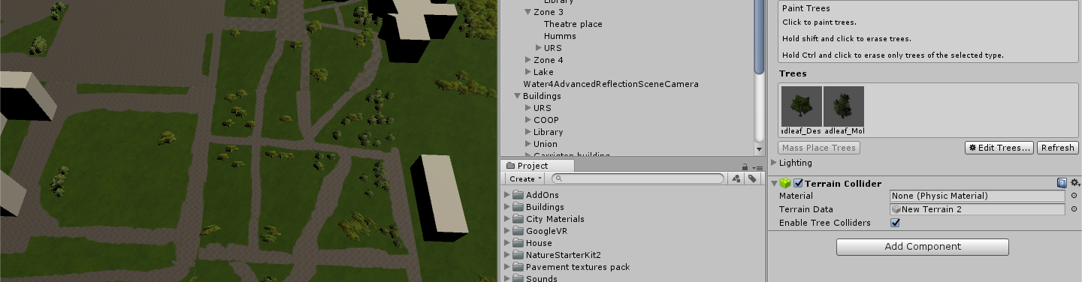

Figure 9 Adding trees to the campus ground using the tree tools in unity.

# References

BrainSock, 2016. *Revit to Unity : Adding Google VR & Teleport.* [Online]   
Available at: https://youtu.be/JbkYLfdHwbg

Darrenlloyd, 2013. *Heightmap creation from OS data. (UK Only).* [Online]   
Available at: http://r3dstar.co.uk/?p=231

Nobiax, 2014. *Yughues Free Pavement Materials.* [Online]   
Available at: https://assetstore.unity.com/packages/2d/textures-materials/brick/18-high-resolution-wall-textures-12567